

Faculty of Technology and Engineering
Chandubhai S. Patel Institute of Technology (CSPIT) Department of Computer Science & Engineering
Date:05/11/2026
Practical Submission

Academic Year | : | 2026-27 | Semester | : | 3rd
Course code | : | CEUE203 | Course name | : | JAVA

Practical No: 09

Program Title: Counter race, Seat booking race, Splitting large array across threads.

Problem Statement: 1. Counter race: several threads each increment a shared counter many times. Run it without synchronization to watch the total come out too low, then make the increment synchronized and confirm it is exactly right every run. 2. Seat booking race: a shared seatsLeft of 5 with about 10 threads each trying to book one seat. Without synchronization show that more than 5 can succeed (oversell); with a synchronized book() exactly 5 do. 3. (For Advanced Learners – home) Split a large array of numbers across several threads that add into one shared total, show the wrong result, then fix it two ways and compare; decide how to measure the difference
Formatted Code:

CounterRaceDemo.java

package practical_9;

// Demonstrates a race condition and how synchronized fixes it.

class Counter {

private int count = 0;

// This method is NOT synchronized.
// Multiple threads can update count at the same time.
public void incrementWithoutSync() {
count++;
}

// This method is synchronized.
// Only one thread can execute it at a time on this object.
public synchronized void incrementWithSync() {
count++;
}

public int getCount() {
return count;
}
}

public class CounterRaceDemo {

// Number of threads and increments per thread.
private static final int THREADS = 10;
private static final int INCREMENTS = 100_000;

public static void main(String[] args) throws InterruptedException {

// ---------------- WITHOUT SYNCHRONIZATION ----------------
Counter unsafeCounter = new Counter();

Thread[] unsafeThreads = new Thread[THREADS];

for (int i = 0; i < THREADS; i++) {
unsafeThreads[i] = new Thread(() -> {
for (int j = 0; j < INCREMENTS; j++) {
unsafeCounter.incrementWithoutSync();
}
});
}

// Start all threads.
for (Thread thread : unsafeThreads) {
thread.start();
}

// Wait until all threads finish.
for (Thread thread : unsafeThreads) {
thread.join();
}

int expected = THREADS * INCREMENTS;

System.out.println("WITHOUT SYNCHRONIZATION");
System.out.println("Expected count : " + expected);
System.out.println("Actual count : " + unsafeCounter.getCount());

// ---------------- WITH SYNCHRONIZATION ----------------
Counter safeCounter = new Counter();

Thread[] safeThreads = new Thread[THREADS];

for (int i = 0; i < THREADS; i++) {
safeThreads[i] = new Thread(() -> {
for (int j = 0; j < INCREMENTS; j++) {
safeCounter.incrementWithSync();
}
});
}

// Start all synchronized threads.
for (Thread thread : safeThreads) {
thread.start();
}

// Wait for all threads to finish.
for (Thread thread : safeThreads) {
thread.join();
}

System.out.println("\nWITH SYNCHRONIZATION");
System.out.println("Expected count : " + expected);
System.out.println("Actual count : " + safeCounter.getCount());
}
}

Output:

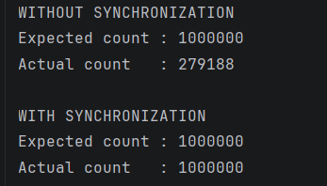

SeatBookinDemo.java

package practical_9;

// Demonstrates how synchronization prevents seat overselling.

class TicketCounter {

private int seatsLeft = 5;

// Unsafe booking method: multiple threads may read the same seatsLeft.
public boolean bookWithoutSync() {

if (seatsLeft > 0) {

// Small delay makes it easier to observe the race condition.
try {
Thread.sleep(10);
} catch (InterruptedException e) {
Thread.currentThread().interrupt();
return false;
}

seatsLeft--;
return true;
}

return false;
}

// Safe booking method: only one thread can check and book at a time.
public synchronized boolean bookWithSync() {

if (seatsLeft > 0) {

try {
Thread.sleep(10);
} catch (InterruptedException e) {
Thread.currentThread().interrupt();
return false;
}

seatsLeft--;
return true;
}

return false;
}

public int getSeatsLeft() {
return seatsLeft;
}
}

public class SeatBookingDemo {

private static final int TOTAL_SEATS = 5;
private static final int THREADS = 10;

public static void main(String[] args) throws InterruptedException {

// ---------------- WITHOUT SYNCHRONIZATION ----------------
TicketCounter unsafeCounter = new TicketCounter();

// Stores how many bookings succeeded.
int[] unsafeSuccess = {0};

Thread[] unsafeThreads = new Thread[THREADS];

for (int i = 0; i < THREADS; i++) {

unsafeThreads[i] = new Thread(() -> {

if (unsafeCounter.bookWithoutSync()) {

// Synchronize this small update so the booking count
// itself does not introduce another race.
synchronized (unsafeSuccess) {
unsafeSuccess[0]++;
}

System.out.println(
Thread.currentThread().getName()
+ " booked a seat (without synchronization)"
);
}
}, "Customer-" + (i + 1));
}

for (Thread thread : unsafeThreads) {
thread.start();
}

for (Thread thread : unsafeThreads) {
thread.join();
}

System.out.println("\nWITHOUT SYNCHRONIZATION");
System.out.println("Successful bookings : " + unsafeSuccess[0]);
System.out.println("Seats left : " + unsafeCounter.getSeatsLeft());

// ---------------- WITH SYNCHRONIZATION ----------------
TicketCounter safeCounter = new TicketCounter();

int[] safeSuccess = {0};

Thread[] safeThreads = new Thread[THREADS];

for (int i = 0; i < THREADS; i++) {

safeThreads[i] = new Thread(() -> {

if (safeCounter.bookWithSync()) {

// Count successful bookings safely as well.
synchronized (safeSuccess) {
safeSuccess[0]++;
}

System.out.println(
Thread.currentThread().getName()
+ " booked a seat (with synchronization)"
);
}
}, "Customer-" + (i + 1));
}

for (Thread thread : safeThreads) {
thread.start();
}

for (Thread thread : safeThreads) {
thread.join();
}

System.out.println("\nWITH SYNCHRONIZATION");
System.out.println("Successful bookings : " + safeSuccess[0]);
System.out.println("Seats left : " + safeCounter.getSeatsLeft());

// Check whether the synchronized booking worked correctly.
System.out.println(
"Exactly 5 bookings? : " + (safeSuccess[0] == TOTAL_SEATS)
);
}
}

Output:

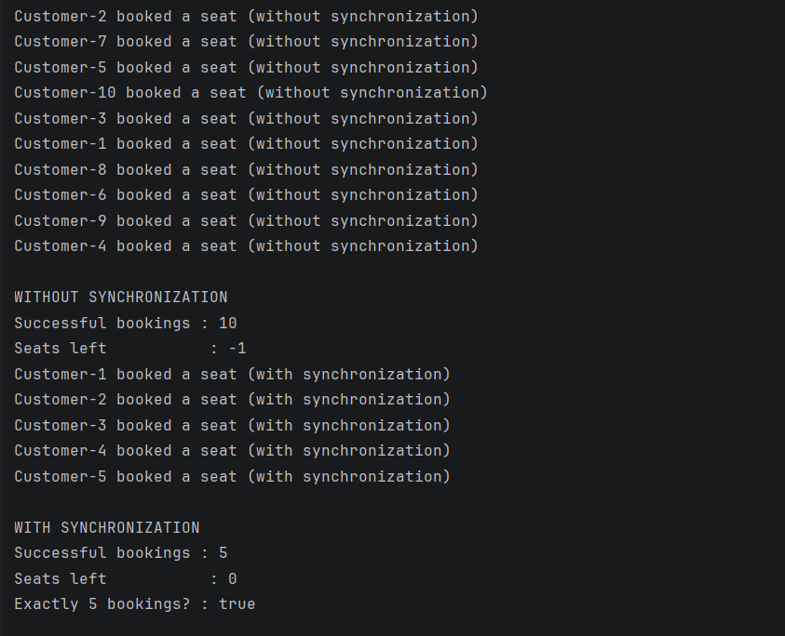

ArraySumRaceDemo.java

package practical_9;

// Demonstrates three ways to calculate an array sum using threads.

class SharedTotal {

long total = 0;

// Unsafe: multiple threads can overwrite each other's updates.
public void addWithoutSync(long value) {
total += value;
}

// Safe: only one thread can update total at a time.
public synchronized void addWithSync(long value) {
total += value;
}

public long getTotal() {
return total;
}
}

public class ArraySumRaceDemo {

// A large array gives the threads plenty of work.
private static final int ARRAY_SIZE = 1_000_000;

// Use several threads, but at least two.
private static final int THREAD_COUNT =
Math.max(2, Runtime.getRuntime().availableProcessors());

public static void main(String[] args) throws InterruptedException {

int[] numbers = new int[ARRAY_SIZE];

// Fill the array with values from 1 to ARRAY_SIZE.
for (int i = 0; i < ARRAY_SIZE; i++) {
numbers[i] = i + 1;
}

// Calculate the correct answer using a normal loop.
long expected = 0;

for (int number : numbers) {
expected += number;
}

System.out.println("Array size : " + ARRAY_SIZE);
System.out.println("Number of threads: " + THREAD_COUNT);
System.out.println("Expected sum : " + expected);

// Divide the array into approximately equal sections.
int chunkSize = (ARRAY_SIZE + THREAD_COUNT - 1) / THREAD_COUNT;

// ------------------------------------------------
// METHOD 1: UNSAFE SHARED TOTAL
// ------------------------------------------------

SharedTotal unsafeTotal = new SharedTotal();
Thread[] unsafeThreads = new Thread[THREAD_COUNT];

long startTime = System.nanoTime();

for (int t = 0; t < THREAD_COUNT; t++) {

final int start = t * chunkSize;
final int end = Math.min(start + chunkSize, ARRAY_SIZE);

unsafeThreads[t] = new Thread(() -> {

// Each thread adds its array section directly
// into the same shared total without synchronization.
for (int i = start; i < end; i++) {
unsafeTotal.addWithoutSync(numbers[i]);
}
});
}

for (Thread thread : unsafeThreads) {
thread.start();
}

for (Thread thread : unsafeThreads) {
thread.join();
}

long unsafeTime = System.nanoTime() - startTime;

System.out.println("\nMETHOD 1: WITHOUT SYNCHRONIZATION");
System.out.println("Calculated sum : " + unsafeTotal.getTotal());
System.out.println("Correct result : " + (unsafeTotal.getTotal() == expected));
System.out.printf("Time taken : %.3f ms%n", unsafeTime / 1_000_000.0);

// ------------------------------------------------
// METHOD 2: SYNCHRONIZED SHARED TOTAL
// ------------------------------------------------

SharedTotal safeTotal = new SharedTotal();
Thread[] safeThreads = new Thread[THREAD_COUNT];

startTime = System.nanoTime();

for (int t = 0; t < THREAD_COUNT; t++) {

final int start = t * chunkSize;
final int end = Math.min(start + chunkSize, ARRAY_SIZE);

safeThreads[t] = new Thread(() -> {

// Each addition is protected by synchronized.
for (int i = start; i < end; i++) {
safeTotal.addWithSync(numbers[i]);
}
});
}

for (Thread thread : safeThreads) {
thread.start();
}

for (Thread thread : safeThreads) {
thread.join();
}

long safeTime = System.nanoTime() - startTime;

System.out.println("\nMETHOD 2: WITH SYNCHRONIZATION");
System.out.println("Calculated sum : " + safeTotal.getTotal());
System.out.println("Correct result : " + (safeTotal.getTotal() == expected));
System.out.printf("Time taken : %.3f ms%n", safeTime / 1_000_000.0);

// ------------------------------------------------
// METHOD 3: THREAD-LOCAL PARTIAL TOTALS
// ------------------------------------------------

// Every thread gets its own array slot for its partial sum.
// No two threads write to the same slot.
long[] partialTotals = new long[THREAD_COUNT];

Thread[] localThreads = new Thread[THREAD_COUNT];

startTime = System.nanoTime();

for (int t = 0; t < THREAD_COUNT; t++) {

final int threadIndex = t;
final int start = t * chunkSize;
final int end = Math.min(start + chunkSize, ARRAY_SIZE);

localThreads[t] = new Thread(() -> {

// Calculate this thread's sum locally.
long localSum = 0;

for (int i = start; i < end; i++) {
localSum += numbers[i];
}

// Store the result in this thread's own slot.
partialTotals[threadIndex] = localSum;
});
}

for (Thread thread : localThreads) {
thread.start();
}

for (Thread thread : localThreads) {
thread.join();
}

// Combine partial totals after all threads have finished.
// The main thread is the only thread doing this addition.
long finalTotal = 0;

for (long partial : partialTotals) {
finalTotal += partial;
}

long localTime = System.nanoTime() - startTime;

System.out.println("\nMETHOD 3: THREAD-LOCAL PARTIAL TOTALS");
System.out.println("Calculated sum : " + finalTotal);
System.out.println("Correct result : " + (finalTotal == expected));
System.out.printf("Time taken : %.3f ms%n", localTime / 1_000_000.0);
}
}

Output:



